Title of the Paper: Feasibility of Longevity Swap for Korean Life Annuity Market

Authors: ChangSoo Lee¹ and Seongmin Kim²

- ChangSoo Lee is professor at the department of statistics and actuarial science of Soongsil University. His contact information is as following:

Email: cslee@ssu.ac.kr
Phone: +82-2-820-0443
Fax.: +82-2-823-1746
Mobile: +82-10-3797-8357
Address: Soongsil University 369 Sangdo-Ro, Dongjak-Ku, Seoul, South Korea

- Seongmin Kim is a Ph.D. student at the department of statistics and actuarial science of Soongsil University.

Abstract
Recently capital market solutions for the risk management of longevity risk have become increasingly important worldwide. Longevity swap is a major tool for that purpose. In longevity swap two parties, a life annuity insurer and a counterparty, enter into an agreement to swap a preset amount for a floating amount, related to the number of surviving people from the reference population, at predetermined time. In Korea capital market solutions for the risk management of longevity risk has not been tried yet. But recently a few life insurance companies in Korea showed interest in it. Longevity swap may be effectively used to reduce additional capital burden from upcoming changes in financial reporting system and regulatory risk management system. In this paper we use stochastic models for the pricing of longevity swap. And feasibility of longevity swap for Korean life annuity market will be evaluated based on suggested models. Mortality data provided by national statistical office of Korea and mortality tables provided by Korea Insurance Development Institue are used for the analysis. We found that feasible structure of longevity swap which satisfies both of insurance company and counterparty is possible.
Introduction
A swap is an agreement by which two parties agree to exchange one or more future cash flows, at least one of which is random. Longevity swap can then be defined as a swap involving at least one random mortality-dependent payments. Dowd et al.(2006) developed a survivor swap to hedge longevity risks. Two parties, an annuity insurer and a counterparty, enter into an agreement to swap a preset amount K(t) for a floating amount S(t), related to the number of surviving people from the reference population, at predetermined time t. To relieve credit risks, they can exchange the net difference between the two payment amounts.
Preset payments the annuity insurer makes depend on the currently expected future survival rates of a certain population agreed upon at the inception of the swap contract. These are derived from expected mortality rates. The counterparty pays an amount depending on the realized survival rates of an index or reference population. These payments are stochastic at the inception of the contract. Theory suggests that the fixed leg payments will have to incorporate a certain premium to attract counterparties. Therefore the amount K(t) the insurer pays will not only reflect expected survival rates but will likely include a risk premium.
This suggests that the longevity swap would have the preset counterparty pay $\left(1+π\right)K\left(t\right)-S(t)$ if this amount is positive, and receive $S\left(t\right)-\left(1+π\right)K\left(t\right)$ otherwise. The premium rate $π$ might be positive, zero, and negative. When we let V[•] be the value of the amount of cashflows, the value of the swap to the preset-rate payer is given as follows:
$$Swap value=V\left[S\left(t\right)\right]-V\left[\left(1+π\right)H\left(t\right)\right]=V\left[S\left(t\right)\right]-\left(1+π\right)V\left[H\left(t\right)\right]$$
The premium $π$ can be set so that the swap value is equal to 0. Preset payments the annuity insurer makes depend on the currently expected future survival rates of a certain population agreed upon at the inception of the swap contract. These are derived from expected mortality rates. The counterparty pays an amount which are determined by uncertain actual survival rates.
Recently capital market solutions for the risk management of longevity risk have become increasingly important worldwide. And pricing of those capital market solutions have become interest of researchers. In Korea capital market solutions for the risk management of longevity risk has not been tried yet. But a few life insurance companies are showing interest in it. Korean insurance companies are preparing for upcoming changes in financial reporting system and regulatory risk management system which will increase capital burden. Under this circunsatnce longevity swap can be effectively used to reduce longevity risk of life annuity products. In this paper we use stochastic models for the pricing of longevity swap. And feasibility of longevity swap for Korean life annuity market is tested. We found that feasible structure of longevity swap which satisfies both of insurance company and counterparty is possible.

Mortality Table Construction for Life Annuities in Korea
Currently mortality rates are determined by Korea Insurance Development Institute(KIDI). Basic methodology of constructing mortality table for the pricing of life annuities reflect improving trend of mortality rates. Following table shows part of improvement factors of mortlity rates for life annuity products which are applied in Korea.
Table 1. Improvement Factors of Mortlity Rates

Gender/  Age Group |  | Improvement Factor (%)
 |  | Development Years
 |  | 1 | 2 | 3 | 4 | 5 | 10 | 20 | 30 | 40 | 50
 | 52 | 4.17% | 4.14% | 4.12% | 4.09% | 4.07% | 3.92% | 3.54% | 3.11% | 2.51% | 1.94%
 | 57 | 4.19% | 4.17% | 4.14% | 4.11% | 4.09% | 3.93% | 3.54% | 3.10% | 2.48% | 1.90%
 | 62 | 4.20% | 4.18% | 4.15% | 4.12% | 4.08% | 3.91% | 3.48% | 3.00% | 2.35% | 1.76%
 | 67 | 3.75% | 3.73% | 3.70% | 3.67% | 3.64% | 3.48% | 3.10% | 2.69% | 2.14% | 1.65%
 | 72 | 3.17% | 3.14% | 3.11% | 3.08% | 3.04% | 2.88% | 2.50% | 2.13% | 1.67% | 1.29%
 | 77 | 2.37% | 2.35% | 2.33% | 2.31% | 2.28% | 2.17% | 1.92% | 1.69% | 1.40% | 1.14%
 | 52 | 4.47% | 4.44% | 4.40% | 4.37% | 4.34% | 4.15% | 3.68% | 3.08% | 2.42% | 1.78%
 | 57 | 4.67% | 4.64% | 4.60% | 4.57% | 4.53% | 4.32% | 3.78% | 3.11% | 2.37% | 1.68%
 | 62 | 4.85% | 4.80% | 4.76% | 4.71% | 4.66% | 4.38% | 3.69% | 2.88% | 2.06% | 1.36%
 | 67 | 4.61% | 4.55% | 4.49% | 4.43% | 4.37% | 4.03% | 3.23% | 2.38% | 1.61% | 1.01%
 | 72 | 4.07% | 4.01% | 3.95% | 3.89% | 3.82% | 3.48% | 2.74% | 1.99% | 1.35% | 0.86%
 | 77 | 3.10% | 3.05% | 3.01% | 2.96% | 2.91% | 2.67% | 2.16% | 1.65% | 1.21% | 0.84%

And mortlity rates for future period is determined by following formula:
$$q_{x}^{2}=q_{x}^{1}*\prod_{i=1}^{n}{(1-r_{x}^{i})}$$
where $q_{x}^{2}$ denotes mortality rate for future period, $q_{x}^{1}$ denotes reference mortality rate and $r_{x}^{i}$ denotes improvement factor.

Models for the Pricing of Longevity Swap

Let the random variable $D_{xt}$ denote the number of deaths in a population at age x and time t. A rectangular data array ($d_{xt}$, $e_{xt}$) is available for the analysis where $d_{xt}$ is the actual number of deaths and $e_{xt}$ is the matching exposure to the risk of death. The force of mortality and empirical mortality rates are denoted by $μ_{xt}$ = ${\hat{m}}_{xt}$= $\frac{d_{xt}}{e_{xt}} .$ The Lee–Carter model structure is $μ_{xt}$ = exp(${\hat{a}}_{x}+{\hat{b}}_{x}{\hat{k}}_{t}$). The structure is designed to capture age–period effects with the ${\hat{a}}_{x}$ terms incorporating the main age effects, averaged over time, and terms ${\hat{b}}_{x}{\hat{k}}_{t}$ incorporating the age specific period trends. We can write $μ_{xt}$ = exp(${\hat{a}}_{x}$ + log F(x,t)) in general, where specifically the mortality reduction factor log F(x,t) = ${\hat{b}}_{x}{\hat{k}}_{t}.$
We now generalize the model structure in order to include age–period–cohort effects by formulating the mortality which reduction factor is F(x,t) = exp($b_{x}^{(0)}l_{t-x}+b_{x}^{(1)}k_{t}$) with an extra pair of terms $b_{x}^{(0)}l_{t-x}$ to represent additional cohort effects. In formulating these structures, we have partitioned the force of mortality $μ_{xt}$ = exp(${\hat{a}}_{x}$ + log F(x,t)) into the product of a static life-table incorporating the main age effects ${\hat{a}}_{x}$ and a dynamic parameterised mortality reduction factor F incorporating the age-specific period ($k_{t}$) and cohort effects ($l_{t-x}$). Mortality data provided by national statistical office of Korea and mortality tables provided by KIDI are used for the analysis.

Basic Structure of Longevity Swap
Longevity swap is mainly used by insurance companies having business in life annuity. They need a swap contract with counterparty like reinsurance company or investment bank. Basically Insurance company provides fixed cash flow determined by the expected survival rates to the counterparty. And the counterparty provides floating cash flow determined by the actual survival rates in return. Following figure shows these exchanges of cash flows.

Figure 1. Structure of Longevity Swap

Main Results of the Analysis
In the following figure we suggest example structure of longevity swap contract. Values of a represent fixed ratios which determine fixed cash flow from insurance company to investment bank. We considered aspect of pure premium only in the analysis.
Figure 2. Cash Flows in Suggested Longevity Swap Contract
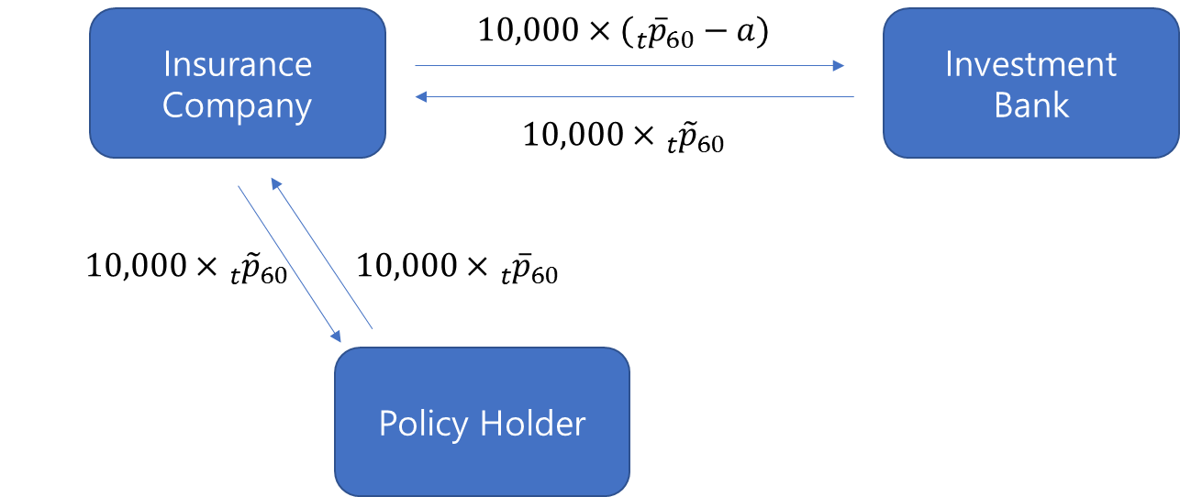
Based on assumptions given in Table 2 present values of expected profits of insurance company and investment bank depeding on the value of a in suggested longevity swap contract are evaluated as given in Table 3.
Table 2. Assumptions for the Evaluation of the Profit
Product Type | Immediate Whole Life Annuity
Age of Policyholder at Policy Issue | 60 Years Old, as of 2016
Number of Policyholders | 10,000
Premium Payment Method | Lump Sum Payment at Policy Issue
Annuity Amount | 1,000,000 Korean Won

Table 3. PV of Expected Profit from the Longevity Swap (Man)
(Unit : million won)
A | PV of Insurnace  Company's profit | PV of Investment Bank's profit
 |  | Mean  (50th percentile) | 1st percentile | 5th percentile
0.0% | 0 | 5,277 | 2,497 | 3,327
0.5% | 1,325 | 3,952 | 1,172 | 2,002
1.0% | 2,650 | 2,627 | -153 | 677
1.5% | 3,975 | 1,302 | -1,478 | -648
2.0% | 5,300 | -23 | -2,803 | -1,973
2.5% | 6,625 | -1,348 | -4,128 | -3,298

References

D. Blake, P. Brockett, S. Cox, and R. MacMinn (2011), “Longevity Risk and Capital Markets: The 2009–2010 Update”, North American Actuarial Journal, Vol.15, No 2

A. Cowley and J. Cummins. (2005), “Securitization of Life Insurance Assets and
Liabilities”, The Journal of Risk and Insurance, Vol. 72, No. 2, p193–226.

S. Cox, and Y. Lin (2007), “Natural Hedging of Life and Annuity Mortality Risks”, North American Actuarial Journal, Vol.11, No. 3

K. Dowd, D. Blake, A. Cairns and P. Dawson. (2006), “Survivor Swaps”, The Journal of
Risk and Insurance, Vol. 73, No. 1, p1–17.

R.D. Lee and L.R. Carter (1992), “Modeling and Forecasting U.S. Mortality”, Journal of the American Statistical Association

Life and Longevity Markets Association (2010), “Longevity Pricing Framework”

M. Purushotham, E. Valdez, and H. Wu (2011), “Global Mortality Improvement Experience and Projection Techniques”, Society of Actuaries

A.E. Renshaw and S. Haberman (2006), “A cohort-based extension to the Lee–Carter model for mortality reduction factors”, Cass Business School, City University of London

