Compressing or Expansion of Morbidity?
The Demand for Annuity and Long-term Care Insurance

Hua Chen, Jin Gao and Wei Zhu

June 2, 2017

Hua Chen
Department of Risk, Insurance and Healthcare Management
Fox School of Business, Temple University
Email: hchen@temple.edu

Jin Gao
Department of Finance and Insurance
Lingnan University, Hong Kong
Email: jingao@ln.edu.hk

Wei Zhu
School of Insurance and Economics
University of International Business and Economics, China
E-mail: zhuwei@uibe.edu.cn

Compressing or Expansion of Morbidity?
The Demand for Annuity and Long-term Care Insurance

Abstract

Individual retirees face two important risks: rising health care costs and increased life expectancy. Health shocks and longevity risk are inherently connected since death represents the end state in an individual’s health state transition process. A longer life expectancy can be attributed to a prolonged time span during which the individual stays healthy, i.e., compression of morbidity (Fries 2005), or associated with a relatively more increase in the length of an unhealthy state, i.e., expansion of morbidity (Olshansky et al. 1991). A third hypothesis (the dynamic equilibrium theory) points to an overall stable relative length of unhealthy life expectancy. There is still no consensus in the literature on which pattern truly captures individuals’ evolution of health states. In this paper, we use a life-cycle model to investigate how the health state transition process affects an individual’s demand for long-term care insurance and life annuity, in addition to other standard investment products such as bonds and stocks. Our paper contributes to the existing literature in several ways. First, we develop a dynamic multistate transition model where the transition probabilities depend on age and calendar time. Second, we answer the question as to what is the demand for long-term care insurance and life annuity under the compression, expansion and dynamic equilibrium hypothesis, respectively.

Key Word: Compression, expansion and dynamic equilibrium of morbidity; multistate transition model; ambiguity and ambiguity aversion; annuity puzzle; long-term care insurance puzzle.
1. Introduction
Individual retirees face two important risks: rising health care costs and longevity risk. For example, health care costs in OECD countries have been increasing steadily in the last few decades (Colombo et al., 2011; Shi and Zhang, 2013), and residual life expectancy at age 60 in these countries has risen by 1-2 years over the past few decades according to an International Monetary Fund report (2012). In this paper, we develop a dynamic multistate transition model where the transition probabilities depend on age and calendar time. We also build a life-cycle model to investigate an optimal mix of retirement products for an individual, including annuity, private long-term care (LTC) insurance, and equity investment in addition to endowed pension income and government sponsored LTC insurance.
One important retirement product we take into account in our model is life annuity, which converts a lump sum amount (initial premium or accumulated wealth) to periodic payouts over the life of investors. Longer life expectancy has been regarded as a promising outcome with the development of the medical science. Increased longevity makes individuals face a risk of outliving their wealth if without appropriate financial planning. Life annuities can play an important role in helping people handle the old-age problem. The classic rational choice theory predicts that annuity purchase is attractive to people (Yaari 1965, Davidoff et al. 2005) and, in the absence of other motivations or constraints, an individual upon facing retirement should annuitize 100% of their wealth. However, this prediction is not consistent with the observation that relatively few households facing retirement choose to annuitize a substantial portion of their wealth, i.e., the so-called “annuity puzzle”. Some literature (Kotlikoff and Summers (1981), Bernheim (1991)) argues that individuals do not annuitize wealth because of their bequest motives. In order to stimulate annuity demand, some new features have been added to traditional annuity products to minimize the bequest concern, e.g., the surviving spouse being provided with a term certain annuity (Purcal and Piggott, 2008).
Another product we consider is private LTC insurance. In the U.S., approximately two thirds of individuals currently aged 65 or older will need some form of LTC, either at home or courtesy of a LTC facility (Chapman, 2012). Thus far, Medicare and Medicaid have largely provided such services. However, given funding deficiencies at both the state and federal government levels, there is an increasing need to fund individuals’ LTC costs through either out-of-pocket savings or private insurance plans. Although medical and technological advances may decrease disability rates and the need for associated support, the number of people who need LTC will increase substantially in the near future.
Closely related to uncertainty of future health costs is the dynamics of individual health state transitions, which we call health shocks in the sense that the longer retirees live in an unhealthy state, the more likely they incur high health care expenditures. There exists an inherent connection between health shocks and longevity since death represents the end state in an individual’s health state transition process. This transition process leads to a connection between the evolution of increased life expectancy (longevity risk) and whether that increased expectation is in healthy or unhealthy states (health shocks).
Three patterns have been characterized in the previous literature: compression of morbidity (Fries, 2005), expansion of morbidity (Olshansky et al., 1991) and the so-called dynamic equilibrium (Manton, 1982). Compression of morbidity postulates that the increase in life expectancy is accompanied by a relatively smaller increase (or even a decrease) in unhealthy life expectancy with longevity increases contributing to increased health state life expectancy, whereas expansion of morbidity asserts an increase in life expectancy is accompanied by a relatively more increase in unhealthy life expectancy. The dynamic equilibrium theory points to an overall stable relative length of unhealthy life expectancy.
There is still no consensus in the literature on which pattern truly captures individuals’ evolution of health states. On the one hand, as argued and examined by Fries (2005), successful technical innovations used in disease control may increase the age occurring some diseases, and thus compression of morbidity occurs. However, as asserted with some evidence by Olshansky et al. (1991), the net effect of successful technical innovations used in disease control has been to raise the prevalence of certain diseases and disabilities by prolonging their average duration. Standing between these two views, Manton (1982) find some evidence that the life expediency of disability or living with some diseases remains stable, although the severity of morbidity is reduced at any given age. Crimmins et al. (2009) estimate the change of life expectancy of disability of the U.S. community-dwelling population aged 70 and older from 1984 through 2000, and find that the expectancy remains almost unchanged while the total life expectancy of the population increases, consistent with the prediction of dynamic equilibrium. Crimmins and Beltran-Sanchez (2011) identify an expansion of morbidity from 1998-2008 in a study where morbidity was defined in terms of loss of mobility functioning among the noninstitutionalized U.S. population. In contrast, Orlando (2014) reported a significant compression of morbidity in the U.S. institutionalized population aged 65+ from 1984-2004. In addition, Majer et al. (2013) estimate the trend of morbidity change of Dutch population aged 55 and older between 1989 and 2030 and find there exists the compression of morbidity for both male and female.
This paper is organized as follows. In Section 2, we develop a discrete time life cycle model to investigate a retiree’s optimal consumption and portfolio choice, taking into account LTC insurance, life annuity, a risky asset and a risk-free asset. In Section 3, we build a multi-state health transition process and use the HRS data to calibrate the transition probabilities and estimate life expectancy. In Section 4, we numerically solve for the retiree’s optimization problem and present the numerical results. In Section 5, we provide conclusion remarks and propose some future research.

2. Life-Cycle Model
We lay out our model in detail as follows. A retiree is endowed with pension income. For the sake of simplicity, we assume the pension is funded through a defined benefit scheme so that the pension income is exogenous. The retiree can purchase private LTC and annuity at her own discretion and then invest liquid wealth into a risky asset and a riskless asset.
2.1. Utility Assumption
In the model, we apply a constant relative risk aversion (CRRA) type utility which has a functional form
$$U(c)=\left\{\begin{aligned}\frac{c^{1-γ}}{1-γ}, &γ>0, γ≠1, \\ ln⁡(c), &γ=1.\end{aligned}\right.$$
The retiree is risk averse with the CRRA utility type and gain utility from consumption $c.$ $γ$ denotes the level of risk aversion.
A household gains utility from leaving bequests. By Ai et al. (2017), we assume the bequest utility takes the form
$v\left(B\right)=\frac{η}{1-γ}{(φ+\frac{B}{η})}^{1-γ}$,
where B is the bequest amount, $γ$ is the relative risk aversion parameter, $η>0$ measures the intensity of the bequest motive, and $φ>0$ is a shift parameter treating bequests as luxury goods.
2.2. Health Dynamics
Following Koijen et al. (2016), retirees’ health dynamics is modeled using three states: (1) good health, (2) poor health requiring some form of LTC, and (3) death. A retiree’ life cycle dynamics evolve across health states according to a Markov chain with an age-dependent one-period transition matrix and two-way transitions allowed between states 1 and 2.
2.3. Long-Term Care Insurance
Long-term care costs increase as health deteriorates and also increase with general inflation. If a constant inflation rate is assumed, the LTC cost for an individual who is in State i (i=2) at time t, ${LTC}_{t}$, can be expressed as
${LTC}_{t}^{i}={LTC}^{i}e^{ft}$,
where ${LTC}^{i}$ is the long-term care expense in State i in the base year and f is a constant inflation rate.
In our proposed model, only healthy individuals (in State 1) are eligible for purchasing LTC insurance. Denote $PI$ the percentage cover of LTC expenses purchased and we assume the purchase of LTC insurance will be available only at the beginning of the retirement (age x). We denote the actuarial present value of future LTC benefits (${APL}_{x}$) without considering expense and profit loadings as
${APL}_{x}=PI\sum_{t}{{p_{x:x+t}^{12}LTC}_{t}^{i}e^{-rt}}$,
where $p_{x:x+t}^{ij}$ as the probability from state i to state j in t periods.
2.4. Equity Investment and Life Annuities
At the retirement age (age x), the retiree can decide to put some portion ($ω_{FA}$) of his liquid wealth ($a_{x}$) into an immediate fixed life annuity account which provides an annuitization amount $\overline{c}$ periodically. Therefore,
$$\overline{c}=\frac{{ω_{FA}a}_{x}}{\sum_{t=0}^{T}{e^{-r\left(t+1\right)}\left(p_{x:x+t+1}^{i3}-p_{x:x+t}^{i3}\right)}}$$
The remaining liquid wealth can be allocated to an external investment vehicle with two options: a risky asset and a riskless asset. Denote $ω_{t}$ the proportion of liquid wealth that is invested in the risky asset at time t. Then the proportion of liquid wealth invested in the riskless asset is $1-ω_{t}$. The retiree can allocate her wealth freely between the risky and riskless accounts periodically to maximize the household’s utility level. We further assume the riskless asset grows at a risk free rate r and the risky asset price follows a Geometric Brownian motion. Therefore the return on the risky asset, $R_{t}$, is normally distributed with mean $μ_{R}$and standard deviation $σ_{R}$, i.e., $R_{t}\sim N(μ_{R},σ_{R}^{2})$.
2.5. Optimization Problem (Objective Function)
Based on the above setting, the utility maximization problem of an x-year-old individual currently in State 1 can be described in the following equation:
$$\max_{{(O_{t})}_{t=0}^{T-1}}\left\{\sum_{t=0}^{T-1}{α^{t}E\left[\sum_{j≠3}{p_{x:x+t}^{ij}U\left(c_{t}\right)+\left(p_{x:x+t}^{i3}-p_{x:x+t+1}^{i3}\right)v(B_{t})|F_{t}}\right]}\right\},$$
where $α$ is the subjective discount parameter and $O_{t}=\left\{ω_{FA}, {PI,c_{t}, ω}_{t}\right\}$. $ω_{FA}$ and $PI$ are determined at $t=0$, which means the retiree will pay the premium for the LTC cost and put in money in the immediate fixed life annuities at $t=0$ and the liquid wealth level will be deducted correspondingly by $ω_{FA}a_{0}+{APL}_{x}$.
Consumption at time t is given by the following equation
$c_{t}=\overline{c}+y_{t}^{i}-\left(1-PI\right){LTC}_{t}^{i}-s_{t}$,
which means consumption at time t equals pension income ($y_{t}^{i}$, pension income at state i during period t) plus periodic fixed annuity benefit ($\overline{c}$) minus out-of-pocket LTC cost ($\left(1-PI\right){LTC}_{t}^{i}$) and periodic savings ($s_{t}$). If $s_{t}$ is positive, the money will be put into the external investment vehicle and the retiree will optimally allocate it between risky and riskless subaccounts. If $s_{t}$ is negative, the money will be withdrawn from the external investment vehicle.
2.6. Two-stage Bellman Equation
We apply dynamic programming to derive the optimal time-varying consumption choice and allocations of portfolios during retirement. Following Gao and Ulm (2012), all state variables are denoted as ${(.)}_{t-}$ and ${(.)}_{t+}$, i.e., the value immediately before and after the transactions at a discrete time t, respectively. The retiree receives pension income $y_{t}$ at $t^{-}$. Still at time $t^{-}$, consumption and long term care cost payment are made. If the retiree does not die, then the retiree determines the investment allocation decision between the fixed and the variable subaccounts at $t^{+}$, which is still at time t but after he obtains pension income, makes decisions regarding consumption and long-term care payment. We also assume that the beneficiary receives the inheritance (value in the external investment vehicle) immediately at $t^{+}$ just after the retiree dies. Therefore we write the Bellman equation in two stages.
From $t^{-}$ to $t^{+}$ (i.e. the first stage), the retiree consumes and gets the utility. If the retiree dies, at $t^{+}$ his beneficiary will receive bequest amount. Therefore, the first stage equation is as follows,
$$V\left(t^{-},i,a_{t-}\right)=\max_{O_{t-}}\left\{α^{t}E\left[U\left(c_{t}\right)+{(p}_{x:x+t}^{i3}-p_{x:x+t+1}^{i3})v\left(B_{t}\right)+({1-p}_{x:x+t}^{i3}+p_{x:x+t+1}^{i3})V(t^{+},i,a_{t+})|F_{t-}\right]\right\},$$
where $a_{0-}$ is the initial wealth level; $a_{0+}=a_{0-}\left(1-ω_{FA}\right)-APL$; $B_{t}=a_{t+}$, $O_{t-}=\left\{c_{t}\right\}$ and $O_{0-}=\left\{c_{0}, ω_{FA},PI\right\}$.
From $t^{+}$ to ${t+1}^{-}$ (i.e. the second stage), the retiree maximizes the value function from optimally allocating between the two subaccounts. Therefore, $V\left(t^{+},i,a_{t+}\right)$ is the expected discounted value of $E\left[V\left({t+1}^{-},i,a_{{t+1}^{-}}\right)|F_{t+}\right]$.
$$V\left(t^{+},i,a_{t+}\right)=\max_{O_{t+}}\left\{αE\left[V\left({t+1}^{-},i,a_{{t+1}^{-}}\right)|F_{t+}\right]\right\},$$
where $O_{t+}$={$ω_{t}$}.
In the allocation process, we apply a trinomial lattice with probabilities$p_{u}$, $p_{m}$ and $p_{d}$ as defined in Gao and Ulm (2012) as follows,
$$p_{u}=\frac{D_{1}ω^{2}+D_{2}ω+D_{3}}{\left(u-1\right)\left(u-d\right)}$$
$$p_{d}=\frac{ω\left(e^{R∆t}-e^{r∆t}\right)+e^{r∆t}-1}{\left(u-1\right)\left(u-d\right)}-\frac{D_{1}ω^{2}+D_{2}ω+D_{3}}{\left(d-1\right)\left(u-d\right)}$$
$p_{m}=1-p_{u}-p_{d}$,
where
$u=e^{σ\sqrt{3∆t}}$,
$d=\frac{1}{u}$,
$D_{1}=e^{(2R+σ^{2})∆t}-2e^{(R+r)∆t}+e^{2r∆t}$,
$D_{2}=(e^{R∆t}-e^{r∆t})(2e^{r∆t}-d-1)$,
$D_{3}=(e^{r∆t}-1)(e^{r∆t}-d)$.
According to this setting, the asset level at time $t^{+}$ can move to one of three levels (${ua}_{t+}$, $a_{t+}$ and ${da}_{t+}$) at time ${t+1}^{-}$. Therefore, the $V\left(t^{+},i,a_{t+}\right)$ can be rewritten as
$$V\left(t^{+},i,a_{t+}\right)=\max_{O_{t+}}\left\{α\left[p_{u}V\left({t+1}^{-},i,{ua}_{t+}\right)+p_{m}V\left({t+1}^{-},i,a_{t+}\right)+p_{d}V\left({t+1}^{-},i,{da}_{t+}\right)\right]\right\}.$$
To maximize $V\left(t^{+},i,a_{t+}\right),$ we take the first derivative on $ω_{t}$ and we can get a closed-form solution $ω_{t}^{*}$,
$ω_{t}^{*}=-\frac{\left(d-1\right)D_{2}\left(V\left({ua}_{t+}\right)-V\left({da}_{t+}\right)\right)+\left(u-1\right)\left(V\left(a_{t+}\right)-V\left({ua}_{t+}\right)\right)\left[\left(u-d\right)\left(e^{R∆t}-e^{r∆t}\right)-D_{2}\right]}{2D_{1}\left[\left(d-1\right)\left(V\left({da}_{t+}\right)-V\left(a_{t+}\right)\right)-\left(u-1\right)\left(V\left(a_{t+}\right)-V\left({ua}_{t+}\right)\right)\right]}$.
By the no-short-selling restriction, $ω_{t}∈[0,1]$ and we only need to check three possible values of $ω_{t}$: ${0, ω}_{t}^{*},1$. If $ω_{t}^{*}<0$ or $ω_{t}^{*}>1$, we will only take 0 or 1.

3. Estimating Health Dynamics
3.1. Definition of the Health States
Following Koijen et al. (2016), we use three health states to model retirees’ health dynamics: good health, poor health requiring long-term care, and death. Because we aim to calibrate retirees’ life-cycle asset allocation including purchasing LTC insurance and annuity, we need to define the health states by using the well-established definition of poor health requiring some forms of LTC. To be specific, following Brown and Warshawsky (2013) and Ai et al. (2017), we define the first two health states as follows. State 1 (good health) is a state having at most difficulties in 0–1 ADLs but no cognitive impairment, or only having major chronic illnesses (e.g., heart problems, diabetes, lung disease, and stroke). State 2 is having 2 or more ADLs or cognitive impairment. These measures are all in the HRS survey. With this operational definition, health states 1–2 in our analysis correspond to categories 1–4, and 5–10, respectively, in Table 1 of Brown and Warshawsky (2013). This definition allows us to obtain the health states of individuals at different ages over 1998–2010.
3.2. Description of the Sample
We use the Health and Retirement Survey (HRS) data to estimate retirees’ health dynamics. The HRS data provides comprehensive demographic, health, and financial information on individuals from preretirement into retirement. Since a key indicator of an individual’s health state (having difficulty with various activities of daily living, or ADLs), has only been consistently surveyed since 1998 and the information about another key indicator, cognition impairment, is missing for 2012, we use 1998–2010 data. Our final sample has 17,215 individuals alive in 1998, with valid responses to questions on ADLs, self-reported health status, four types of major chronic illnesses (i.e., heart problems, diabetes, lung disease, and stroke), and cognitive ability.
3.3. Health Transition Probabilities
After defining the three health states, we estimate the transition probabilities between the health states using an ordered probit model. The outcome variable is the health state at two years from the present interview. The explanatory variables are dummies for present health and 65 or older, a quadratic polynomial in age, marriage, education years, log income, six types of major chronic illnesses (i.e., hypertension, cancer, heart problems, diabetes, lung disease, and stroke), and the interaction of the dummies with the age polynomial and major chronic illnesses, and log income, and cohort dummies.
Figure 1 and Figure 2 report the estimated transition probabilities for male and female by age and birth cohort, which are the predicted probabilities from the ordered probit model, respectively. The 4 lines in each panel represent the 4 cohorts in our sample. Note that estimated transition probabilities from poor health to other health states over age are much less smooth than those from good health, reflecting the fact that the observations lying in poor health are much less than those in good health. In Figure 1 and Figure 2, the mortality increases rapidly with age, especially conditional on being in poor health. There is significant variation on the transition probabilities across cohorts, in which the older male cohorts are more likely to be dead or become poor healthy and less likely to become good healthy. The patterns for male retirees are consistent with those reported by Koijen et al. (2016). The older female cohorts, however, are more likely to be dead or become poor healthy conditional on being in good health, but they are less likely to be dead or become good healthy conditional on being in poor health.
Figure 1. Estimated health transition probabilities for male.
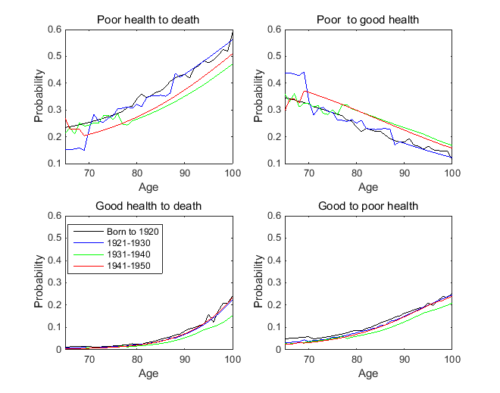
Note: An ordered probit model is used to predict the health state at two years from the present interview. The explanatory variables are dummies for present health and 65 or older, a quadratic polynomial in age, marriage, education years, log income, six types of major chronic illnesses (i.e., hypertension, cancer, heart problems, diabetes, lung disease, and stroke), log of income, and the interaction of the dummies with the age polynomial and major chronic illnesses, and log income, and cohort dummies. The sample consists of males aged 65 and older in the Health and Retirement Study from 1992 to 2010.

Figure 2. Estimated health transition probabilities for female.
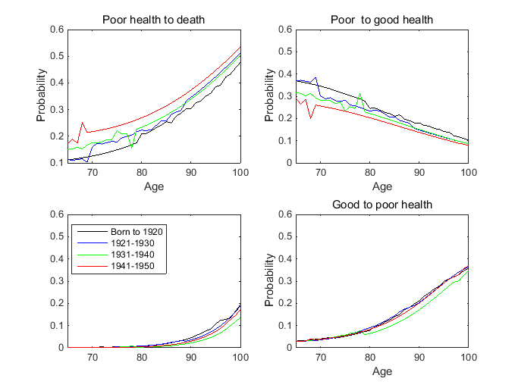
3.4. Compression or Expansion
Table 1 reports retirees’ total life expectancy and life expectancy in good and poor health states for cohorts 1-4. Roughly speaking, both male cohort and female cohort have a larger total life expectancy as they become younger. As they become younger, male cohort’s life expectancy in poor health increases whereas female cohort’s life expectancy in poor health decreases. We find that the ratio of life expectancy in poor health to total life expectancy (both for male and female) decreases for younger cohorts, suggesting evidence of compression of morbidity. We also find that the ratio for female is significantly larger than that for male, meaning that female on average live longer than male but female spend a higher proportion of their remaining life time in an unhealthy state than male do.
Table 1. Life Expectancy in Good and Poor Health States

 |  | Cohort1 | Cohort2 | Cohort3 | Cohort4
Female | Life expectancy in good health (years) | 18.36 | 17.99 | 18.68 | 17.39
 | Life expectancy in poor health (years) | 3.21 | 3.09 | 3.01 | 2.84
 | Total life expectancy (years) | 21.57 | 21.08 | 21.69 | 20.23
 | Ratio of life expectancy in poor health to total life expectancy | 14.87% | 14.65% | 13.88% | 14.04%
Male | Life expectancy in good health (years) | 14.22 | 16.48 | 18.07 | 17.67
 | Life expectancy in poor health (years) | 1.92 | 1.94 | 1.98 | 1.97
 | Total life expectancy (years) | 16.14 | 18.42 | 20.05 | 19.64
 | Ratio of life expectancy in poor health to total life expectancy | 11.90% | 10.53% | 9.89% | 10.01%

4. Optimal Asset Allocation
4.1. Parameter Setting
Since our model has no closed form solution, we apply numerical solutions to retirees’ optimal asset allocation. We assume the retiree makes decisions monthly. She makes all her decisions at the beginning of every month. Following Gao and Ulm (2012), we use the two-stage Bellman equations and apply a two-dimensional lattice. We solve the utility optimization problem by backward induction from age 100. We discretize periodic asset value $A=[a_{min},a_{max}]$ into 31 nodes. The baseline parameter values are setting as follows.
Table 2. Parameter setting

Subjective discount rate (Annual) | $$α$$ | 1/1.02=0.98
Risk free rate (Annual) | r | 2%
Inflation rate (Annual) | f | 1%
Expected return of risky subaccount (Annual) | R | 4%
Standard deviation of risky return (Annual) | $$σ$$ | 15.7%
Pension income (Monthly) | y | 0.03
Coefficient of relative risk aversion | $$γ$$ | 3
Intensity of the bequest motive | $$η$$ | 47.6
shift parameter of bequest | $$φ$$ | 7.28
We take health transition probability matrixes for 4 cohorts as 4 basic scenarios for analysis. Based on HRS data, we obtain the estimated distribution of health states 1–3 at 65 as (0.9566, 0.0534, 0) for males and (0.9425, 0.0575, 0) for females.
4.2. Optimal Purchase of Long-Term Care Insurance and Annuity
We allow retirees to purchase both LTC insurance and annuity simultaneously at the retirement. The retiree’s optimal annuitization turns out to be 0 under both the healthy state and the unhealthy state. The zero annuitization is driven by two forces. First, in our parameter setting, a retiree receives social security income 0.03 per month, which plays the same role as annuity and then, as Pashchenko (2013) pointed out, to some extent crows out the demand of annuity. Second, as Reichling and Smetters (2015) clarified, when health dynamics and the resulting stochastic mortality and medical cost (LTC cost in our context) are taken into account, individuals’ annuitization becomes significantly low.
The retiree’s optimal purchase of LTC insurance varies significantly across cohorts and health states. As shown in Figure 1, compared with healthy male retirees, the unhealthy male retirees, whatever the older cohort (cohort 1) or the younger cohort (cohort 4), always prefer to purchase more LTC insurance. When retirees are healthy, the younger cohort has less demand on LTC insurance than the older ones; when they are unhealthy, the younger cohort has larger demand than the older ones because younger cohorts’ premiums are lower. As we have shown in Table 1, the younger male cohort has longer life expectancy in both good health and poor health than the older one, and the younger’s life expectancy in good health is relatively larger. As a result, healthy younger cohort expects to live longer in good health than the older cohort and thus has a lower willingness to purchase LTC insurance. In contrast, unhealthy younger cohort expects to live longer in poor health than the older cohort and thus has a higher demand on LTC insurance.
Figure 1. Male retirees’ optimal purchase of long-term care insurance
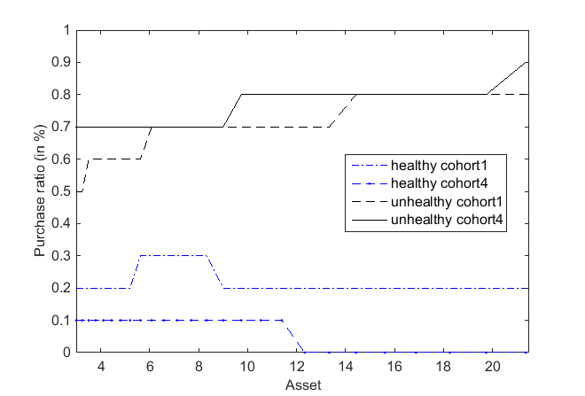
4.3. Optimal consumption and asset allocation
Retirees’ life-cycle optimal consumption and asset allocation path can also be obtained by numerical analysis. As an illustration, Figure 2 reports male retirees’ life-cycle optimal consumption and asset allocation path over age when their asset is $144,255 (the similar pattern occurs for other assets). Retirees’ consumption and asset allocation exhibits a reasonable pattern: with aging, they consume more and allocate less risky asset. The healthy younger cohort (cohort1) consume less but allocate higher risky asset than the healthy older cohort (cohort1), reflecting the fact that the younger cohort has a longer life expectancy in good health than the older one. In contrast, the unhealthy younger cohort’s consumption and risky asset proportion are close to those of the unhealthy older cohort, reflecting the trade-off that the younger cohort has a longer life expectancy in both poor health and good health than the older one.
Figure 3 reports optimal consumption and asset allocation path for male retirees aged 80. With their asset increases, healthy retires’ consumption ratio increases slightly whereas unhealthy ones’ consumption ratio decreases significantly. The asset allocation exhibits different pattern as asset increases: both healthy and unhealthy retirees’ risky asset proportion decreases. The comparison between the younger cohort and the older cohort exhibits the same pattern as shown in Figure 2.
Figure 2. The optimal consumption and asset allocation over age for male with asset $144,255
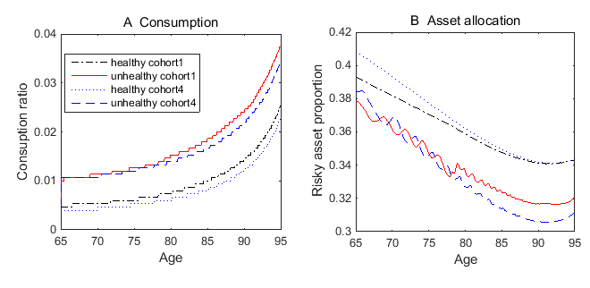
Figure 3. The optimal consumption and asset allocation over asset for male aged 80
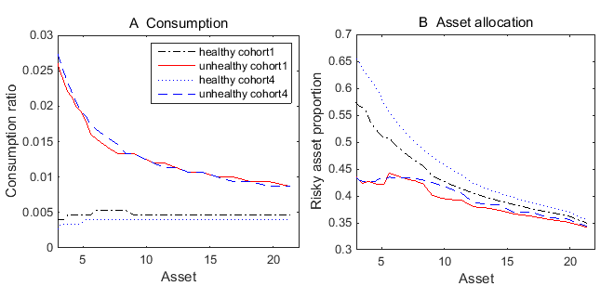
5. Conclusion
In this paper, we develop a dynamic multistate transition model where the transition probabilities depend on age and calendar time. We estimate total life expectancy and life expectancy in an unhealthy state. We find that the younger cohort exhibit a larger life expectancy and that they spend relatively less time in an unhealthy state. This result provides supporting evidence to compression of mobility.
We then use a life-cycle model to investigate how the health state transition process affects an individual’s demand for LTC insurance and life annuity, in addition to other standard investment products. We find that an individual purchases zero annuity when health dynamics and the resulting stochastic mortality and LTC costs are taken into account, consistent with the conclusions in Reichling and Smetters (2015). We also find that the optimal demand for LTC insurance varies significantly across cohorts and health states: when retirees are healthy, younger cohorts have less demand on LTC insurance than older cohorts; when they are unhealthy, younger cohorts have larger demand than older cohorts.
Health status transition (and mortality improving) is a stochastic process. Imprecise knowledge, finite data and inaccurate estimation on the transition probabilities impose great uncertainty on our results. Therefore, a line of future research is to incorporate ambiguity and ambiguity aversion to our model in the sense of Knight (1921). We can resolve the optimal portfolio choice problem in three scenarios. The first scenario is the baseline model where there is no parameter uncertainty (ambiguity). In the second scenario, we can assume an individual recognize ambiguity but act in an ambiguity-neutral way. I.e., the retiree can Bayesian update her belief about the transition probabilities given available information at the end of each period and then adjust her portfolio choice accordingly. In the third scenario, we can allow ambiguity aversion to play a role. In this way, we can investigate the effect of ambiguity and ambiguity aversion on a retiree’s retirement planning.

References:
Ai, J., P.L. Brockett, L.L. Golden, and W. Zhu, 2017, Health State Transitions and Longevity Effects on Retirees’ Optimal Annuitization, Journal of Risk and Insurance, 84: 319-343
Alary, D., Gollier, C., and Treich, N. (2013) The Effect of Ambiguity Aversion on Insurance and Self-Protection, The Economic Journal, 123 (573): 1188-1202.
Ameriks, J., A. Caplin, S. Laufer, and S. Van Nieuwerburgh, 2011, The Joy of Giving or Assisted Living? Using Strategic Surveys to Separate Public Care Aversion From Bequest Motives, Journal of Finance, 66(2): 519-561.
Ameriks, J., Caplin, A., Laufer, S., and Van Nieuwerburgh, S. (2011). The joy of giving or assisted living? Using strategic surveys to separate public care aversion from bequest motives. Journal of Finance, LXVI(2), 519-561.
Anderson, E., Hansen, L.P., and Sargent, T. (2000) Robustness, Detection and the Price of Risk. Mimeo.
Colombo, F., Llena-Nozal, A., Mercier, J., and Tjadens, F. (2011). Help wanted? Providing and paying for long-term care. OECD Health Policy Studies. OECD Publishing, Paris, France.
Chapman, Corin R., (2012), A Conversation on Responsibility, The Actuary, Society of Actuaries, 8:6, p. 8‐10.
Chen, Hua, Samuel H. Cox and Shaun S. Wang (2010). Is the Home Equity Conversion Program in the United States Sustainable? Evidence from Pricing Mortgage Insurance Premiums and Non- Recourse Provisions Using the Conditional Esscher Transform, Insurance: Mathematics and Economics, 46(2): 371-384.
De Nardi, M., E. French, and J. B. Jones, 2010, Why Do the Elderly Save? The Role of Medical Expenses, Journal of Political Economy, 118(1): 39-75.
Davidoff, T. (2010). Home equity commitment and long-term care insurance demand. Journal of Public Economics, 94: 44-49.
Ellsberg, D. (1961) Risk, Ambiguity, and the Savage Axioms, Quarterly Journal of Economics 75(4): 643-669.
Epstein, L., and Schneider, M. (2003) Recursive Multiple-priors, Journal of Economic Theory, 113:1-31.
Fong, J. H., Shao, A. W., and Sherris, M. (2015). Multi-state actuarial models of functional disability. North American Actuarial Journal, 19(1), 41-59.
Gilboa,I ., and Schmeidler, D. (1989) Maxmin Expected Utility Theory with Non-unique Prior. Journal of Mathematical Economics 18: 141-153.
Hansen, L. P. and Sargent, T.J. (2001) Robust Control and Model Uncertainty, American Economic Review 91: 60–66.
Hanewald, K., Post, T., and Sherris, M. (2013). Portfolio choice in retirement - What is the optimal home Equity release product? UNSW Australian School of Business Research Paper No. 2013ACTL16.
International Monetary Fund (2012). Global Financial Stability Report, April 2012. World Economic and Financial Surveys 0258-7440
Koijen R., S. Van Nieuwerburgh, M. Yogo, 2016, Health and Mortality Delta: Assessing the Welfare Cost of Household Insurance Choice, Journal of Finance, 71(2): 957-1009.
Klibanoff, P., Marinacci, M., and Mukerji, S. (2005) A Smooth Model of Decision Making under Ambiguity, Econometrica 73: 1849-1892.
Knight, F. (1921) Risk, Uncertainty and Profit. Boston: Houghton Mifflin.
Li, J. S.-H., M. R. Hardy, and K. S. Tan. 2010. On Pricing and Hedging the No-Negative-Equity-Guarantee in Equity Release Mechanisms. Journal of Risk and Insurance 77: 499-522.
Nakajima, M. and Telyukova, I. A. (2014). Reverse mortgage loans: A quantitative analysis. Federal Reserve Bank of Philadelphia Working Paper No. 14-27.
Pashchenko, S., 2013, Accounting for Non-Annuitization, Journal of Public Economics, 98: 53-67.
Reichling F., K. Smetters, 2015, Optimal Annuitization with Stochastic Mortality and Correlated Medical Costs, American Economic Review, 105(11): 3273-3320.
Secretariat of the Steering Committee on Population Policy (2014), Thoughts for Hong Kong: Public Engagement Exercise on Population Policy, Chief Secretary for Administration's Office, Hong Kong.
Shao, W., H. Chen, M. Sherris (2015), Managing Retirement Risks with Reverse Mortgage Loans and Long-Term Care Insurance, working paper, University of New South Wales.
Shi, P. and Zhang, W. (2013). Managed care and health care utilization: Specification of bivariate models using copulas. North American Actuarial Journal, 17(4), 306-324.

Many papers study the pricing of life annuity, and how much and when to annuitize. The literature includes Yaari (1965), Richard (1975), Chen et al. (2006), Milevsky and Young (2002), Brown (2001), Poterba (1997), Brown et al. (1999), Brown and Poterba (2000); Brown and Warshawsky (2001), Kapur and Orszag (1999), and Blake et al. (2003).
Ameriks et al. (2011) and Pashchenko (2013) apply the same form of bequest utility function and give a detailed explanation.
Between two neighboring nodes, we define jump size following a trinomial tree setting, i.e. let $u=e^{σ\sqrt{3∆t}}$ is the jump size, and $a_{l}=a_{1}u^{l-1}$, for $l=2,3,…,31.$ Therefore, at any given period t, we set a state space with 31 asset levels.
We set $η=47.6$and $φ$=7.28 as in Table IV of Ameriks et al. (2011).

